Pumping Lemma

1. PL is used to prove that a language is not regular
2. It cannot be used to prove that a language is regular

If A is a RL, then A has a pumping length ‘P’ such that any string ‘S’ where |S|>=P may be divided into 3 parts S=XYZ such that the following conditions must be true

1. xyiz € A for every i>=0
2. |Y|>0
3. |XY|<=P

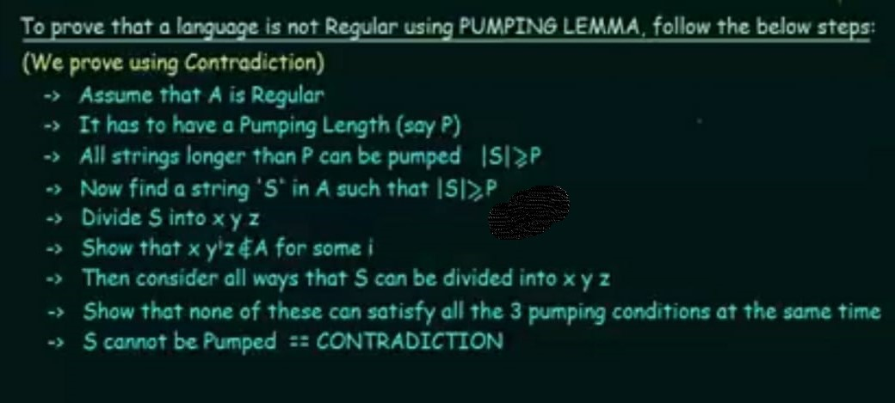

Using PL prove that the language A={anbn|n>=0} is not regular

Assume A is regular

Pumping length = P

S= apbp

Divide S into X Y Z

P=7

S= aaaaaaabbbbbbb

Case 1 XYiZ->XY2Z / example i=2

Y is in ‘a’ part aa aaaaaaaa abbbbbbb

aa aaaa abbbbbbb

x y z 11≠7

case 2

Y is in ‘b’ part aaaaaaabb bbbbbbbb b

7≠11

aaaaaaabb bbbb b

x y z

case 3 aaaaa aabbaabb bbbbb

Y is in ‘a’ and ‘b’ part not follow pattern

aaaaa aabb bbbbb

x y z

|XY|<=P

P=7

CASE 1

6<=7

CASE 2

13<=7

CASE 3

9<=7

ALL THREE CASES CDTN NOT SATISFIED

1. A={YY|Y€(0,1)\*}

Assume A is regular

It must have a pumping length = P

S=0p10p1

S->X Y Z

P=7

0000000100000001

00 0000 0100000001

X Y Z

XYiZ->XY2Z / example i=2

00 00000000 0100000001

String doesnot lie in the language

|y|>0

|XY|<=P

6<=7